**CSE-3024 Web Mining**

**Digital Assignment 2**

**Alokam Nikhitha**

**19BCE2555**

**Experiment 6**

Aim

Write a python program to find the centrality (degree, closeness and betweenness) and prestige (degree and proximity) for the given graph:

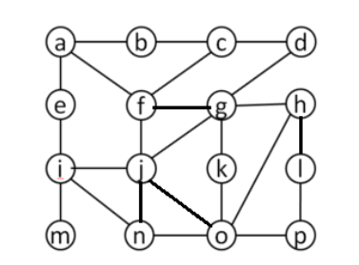

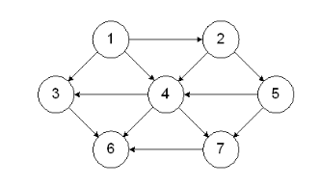

**Problem statement:**

To perform the a program to find centrality and Prestige of the given Networks.

**Centrality**

**Procedure:**

* Firstly, we will import the necessary libraries( networkx and matplotlib ).
* Next, we instantiate a Graph G, using networkx’s .Graph method.
* Then using .add_edge method we create our given graph.
* Later, We then print our graph using matplotlib’s .show method.
* To find the degree of each node, we use degree_centrality method of networkx.
* To find the closeness of each node, we use closeness_centrality method of netowrkx.
* To find the betweenness of each node, we use betweenness_centrality method of networkx.

**Code:**

#importing required Libraries.

import networkx as nx

import matplotlib.pyplot as plt

#Designing the given undirected Graph

G = nx.Graph()

G.add_edge('a','b')

G.add_edge('a','e')

G.add_edge('a','f')

G.add_edge('b','c')

G.add_edge('c','d')

G.add_edge('c','f')

G.add_edge('d','g')

G.add_edge('e','i')

G.add_edge('f','g')

G.add_edge('f','j')

G.add_edge('g','h')

G.add_edge('g','j')

G.add_edge('g','k')

G.add_edge('h','l')

G.add_edge('h','o')

G.add_edge('i','j')

G.add_edge('i','n')

G.add_edge('i','m')

G.add_edge('j','n')

G.add_edge('j','o')

G.add_edge('k','o')

G.add_edge('l','p')

G.add_edge('n','o')

G.add_edge('o','p')

nx.draw(G, with_labels=True)

#centrality Degree of nodes

for node in G.nodes():

print(node, nx.degree_centrality(G)[node])

#closeness centrality of nodes

for node in G.nodes():

print(node, nx.closeness_centrality(G)[node])

#betweenness Centrality of the nodes

for node in G.nodes():

print(node, nx.betweenness_centrality(G)[node])

**Code Snippets and Outputs:**

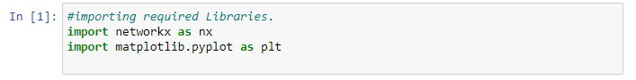

Here we are importing all the required Libraries.

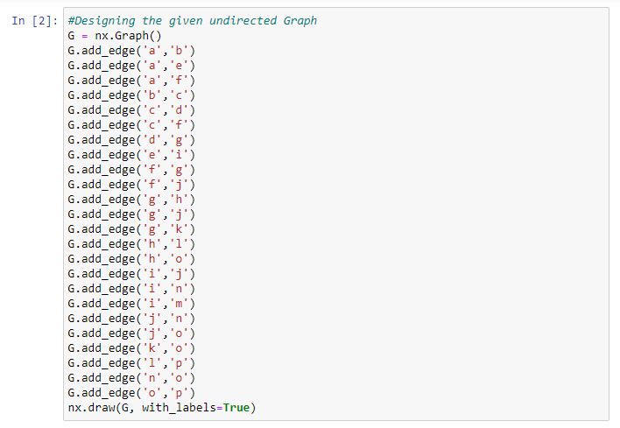

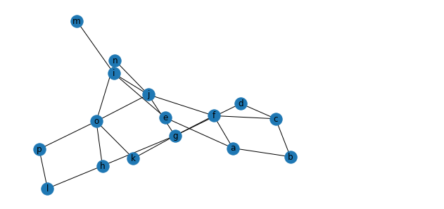

Here we are Initiating our graph using Graph method of networkx and then we make graph by adding each edge to their respective vertices.

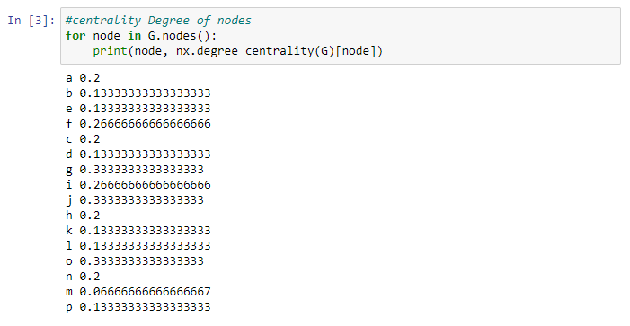

Here we are printing the degree of each node using degree_centrality method of networkx.

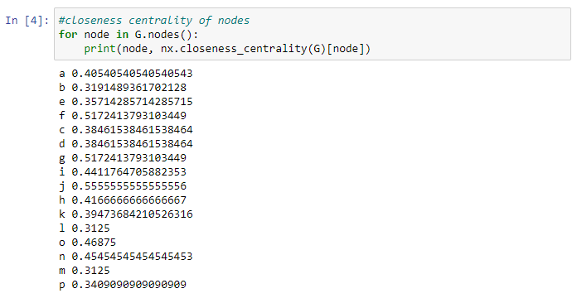

Here we are printing closeness of each node using closeness_centrality method.

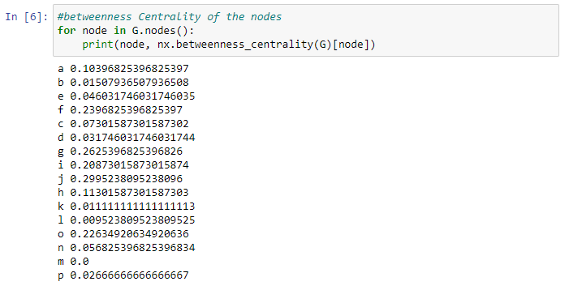

Here we are printing betweenness of each node using betweenness_centrality method.

**Results and Output**



This the picture of the undirected graph that we have taken

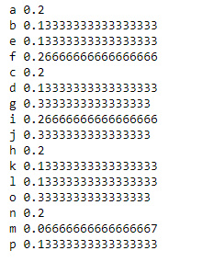

Degree of the nodes in the taken graph

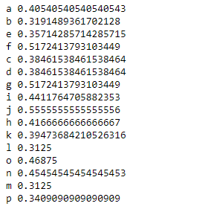

Closeness of the nodes in the taken graph

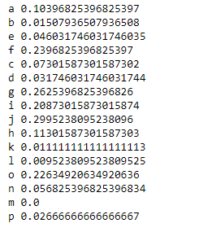

Betweenness of the nodes in the taken graph.

**Prestige**

**Procedure:**

* Firstly, we will import the required libraries (networkx and matplotlib libraries).
* Later, we instantiate a Graph G, using networkx’s .Graph method.
* Later using .add_edge method we create our given graph.
* We then print our graph using matplotlib’s .show method.
* To find degree of each node in our graph, we find the number of incoming edges to each node and then divide it by 6 (number of nodes – 1).
* To find Proximity of each node, we find the distance of that node to each of the other node, then we sum it and finally we divide it by the number of nodes.
* We then print our results.

**Code:**

#Importing Libraries

import networkx as nx

import matplotlib.pyplot as plt

#Initiating and designing graph

G = nx.DiGraph()

G.add_edge('1','2')

G.add_edge('1','3')

G.add_edge('1','4')

G.add_edge('2','4')

G.add_edge('2','5')

G.add_edge('3','6')

G.add_edge('4','3')

G.add_edge('4','6')

G.add_edge('4','7')

G.add_edge('5','4')

G.add_edge('5','7')

G.add_edge('7','6')

nx.draw(G, with_labels=True)

plt.show()

#Degree Calculation

n_nodes = 7

print("Node\tDegree")

for node in G.nodes():

print(node, "\t", len(G.in_edges(node))/(n_nodes-1))

#Proximity Calculation

distance = []

temp_dis = 0

n = 0

for dest in G.nodes:

temp_dis = 0

n = 0

for src in G.nodes:

if (nx.has_path(G,src,dest) == True):

temp_dis = temp_dis + nx.shortest_path_length(G,source = src,target = dest)

n = n + 1

if temp_dis == 0:

distance.append([dest, 0])

else:

distance.append([dest, temp_dis/(n - 1)])

print("Node\tProximity")

for i in distance:

print(str(i[0]) + " \t " + str(i[1]))

**Code Snippets and Outputs:**

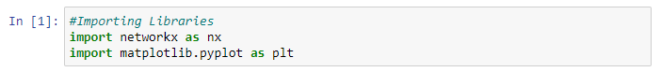

Here we are importing our libraries. We import networkx as nx and matplotlib.pyplot as plt.

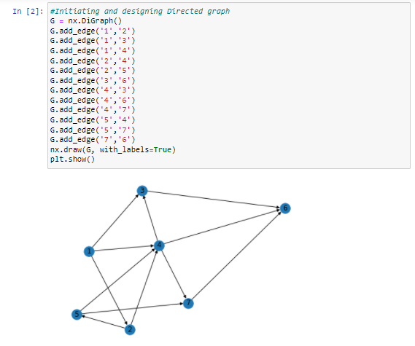

Here we initiate our graph using DiGraph method for directional graph. Then we add the edges of our graph using add_edge method.

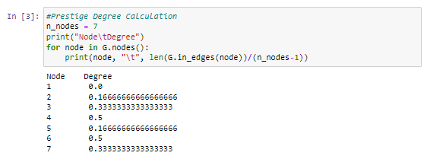

Here we are printing the Prestige degree of each node in our graph.

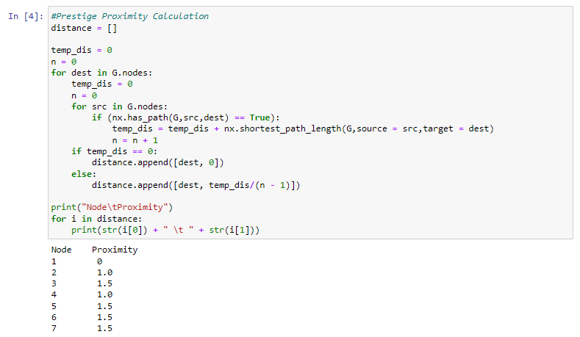

Here we have calculated the Prestige Proximity of each node in our graph.

**Results and Output**

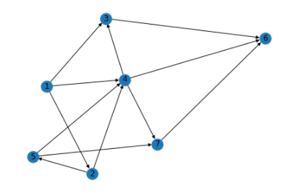

The Directed graph that we have taken

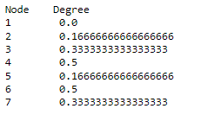

Degree of the nodes in the taken graph.

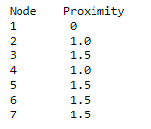

Proximity of the nodes in the taken graph.

**Page Rank**

Question

Write a python program to find the ranks for the given graph.

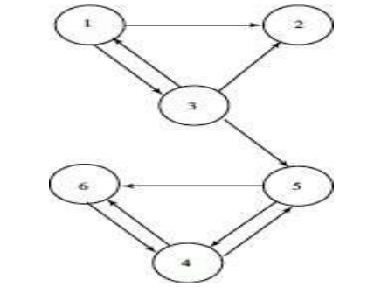

Perform 7 iteration and print the final iteration value only.

**Problem statement:**

Python program to find the Page Rank of all the nodes for the given Graph after 7 iterations.

**Procedure:**

-Firstly, we import the necessary libraries of numpy, scipy and sparse.

-Then write a compute page rank function, which takes in three input parameters, namely, links, damping factor and number of iterations.

-We initialize the damping factor to a standard 0.85 value and number of iterations to 7 as mentioned in question.

-Then we use that function to compute page rank of each page in our network.

**Code:**

#Alokam Nikhitha 19BCE2555

import scipy

from scipy import sparse

import numpy

def ComputePageRank(links, c=0.85, iteration = 7):

count = 0

ones = numpy.ones(len(links))

sources = [x[0] for x in links]

targets = [x[1] for x in links]

n = max(max(sources), max(targets)) + 1

HT = sparse.coo_matrix((ones, (targets, sources)), shape=(n, n))

num_outlinks = numpy.array(HT.sum(axis=0)).flatten()

HT.data /= num_outlinks[sources]

d_indices = numpy.where(num_outlinks == 0)[0]

r = numpy.ones(n) / n

while True:

previous_r = r

r = c * (HT * r + sum(r[d_indices])/n) + (1.0 - c)/n

# r.sum() ≈ 1 but prevent errors from adding up.

r /= r.sum()

count = count+1

if(count >iteration):

# if scipy.absolute(r - previous_r).sum() < epsilon:

return r

print(ComputePageRank([(0,1), (0,2), (2,0),(2, 1),(2, 4),(3, 4),(3,5),(4,3),(4,5), (5,3) ]))

**Code Snippets and Outputs:**

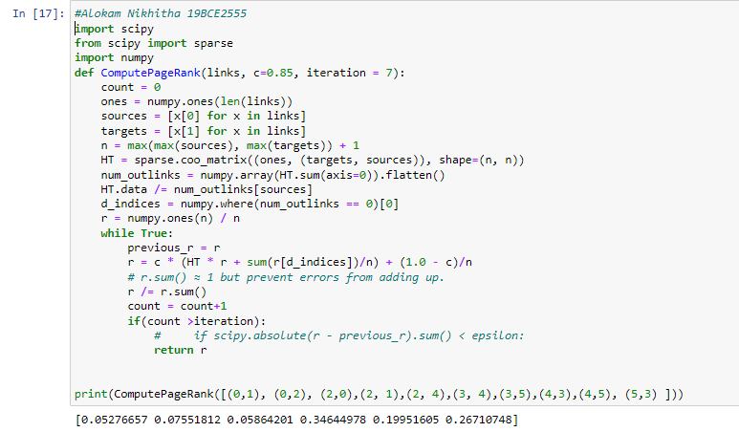

we are importing our libraries. We import scipy, numpy and sparse from scipy. The computePageRank function returns a list of page ranks for each page in our network. It accepts three parameters as input: the links between our network's nodes, the damping factor, and the number of iterations. As stated in our query, we set the damping factor to a standard of 0.85 and the number of iterations to 7.

The page rank of each page in our network has been calculated here.

We renamed each node in our question because we didn't have a 0 node and counting in Python starts at 0. They are each decremented by one.

1 → 0 2 → 1 3 → 2 4 → 3 5 → 4 6 → 5

**Results:**



The page rank of each node in our network is as follows:

Node 1 → 0.05276657

Node 2 → 0.07551812

Node 3 → 0.05864201

Node 4 → 0.34644978

Node 5 → 0.19951605

Node 6 → 0.26710748

Sum of page rank of each node in our network is 1.

The nodes in decreasing order of page ranks are: Node 4 > Node 6 > Node 5 > Node 2 > Node 3 > Node 1